
Airowire Networks Pvt Ltd

Azure Storage

Implementing Azure Blob Storage with a Web Application

1. Objective
In this lab, students will learn how to:
- Create an Azure Storage Account
- Create a Blob Container
- Build a simple Python web application
- Upload files from the application to Azure Blob Storage
- Verify the stored files in Azure Portal

2. Prerequisites
Before starting this lab, ensure the following resources are available:
- Azure account access
- Azure Virtual Machine (VM)
- Python installed on the VM

3. Architecture Overview
The application will work as follows:
User Browser
│
▼
Python Web Application (VM)
│
▼
Azure Storage Account
│
▼
Blob Container
│
▼
Stored Files (Employee Photos)

4. Step 1 – Create Azure Storage Account
- Open the Azure Portal. https://portal.azure.com
- In the search bar, type: Storage Accounts
- Click Create.

Fill the configuration:
Basic tab
Setting | Value
Subscription | Select your subscription
Resource Group | Same as VM
Storage Account Name | Give unique name
Region | Same region as VM
Performance | Standard
Redundancy | Locally Redundant Storage (LRS)

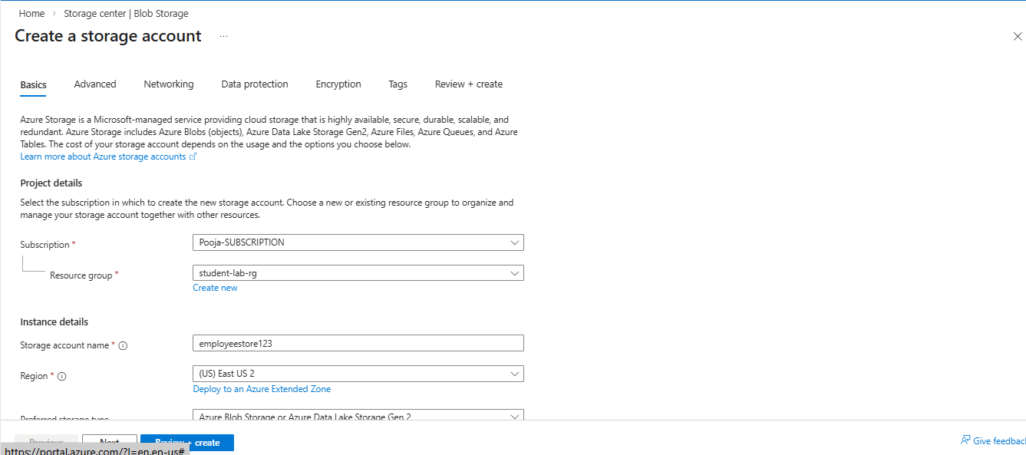
Fig.1

Next go to Advanced tab enable Allow enabling anonymous access on individual containers

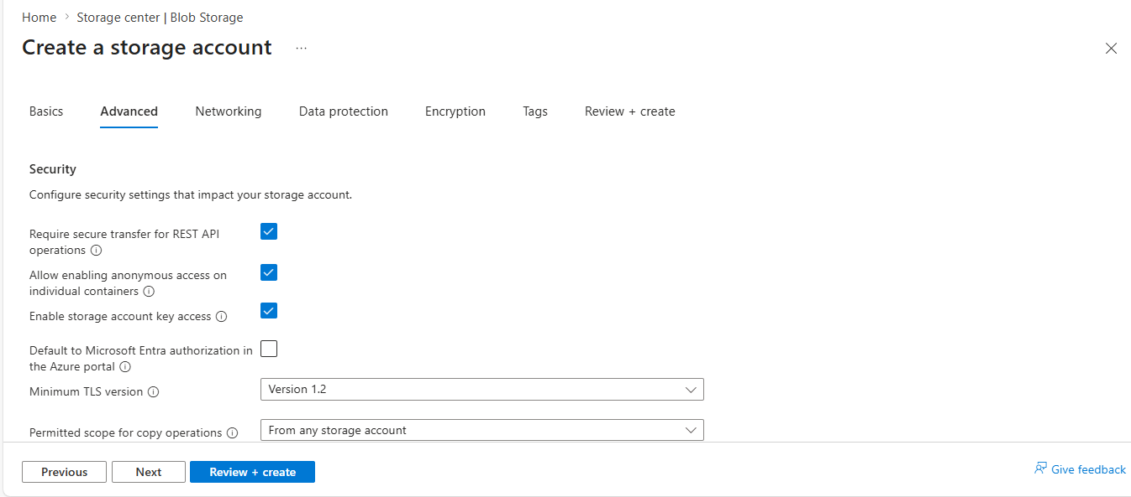
Fig 2
- Click
Review + Create
- Click Create
Wait for deployment to complete.

Step 2 – Create Blob Container
- Open the created Storage Account.
- Navigate to:
Data Storage → Containers
- Click:
+ Container
- Enter the following details:
Container Name : employeephotos
Public Access Level : Blob
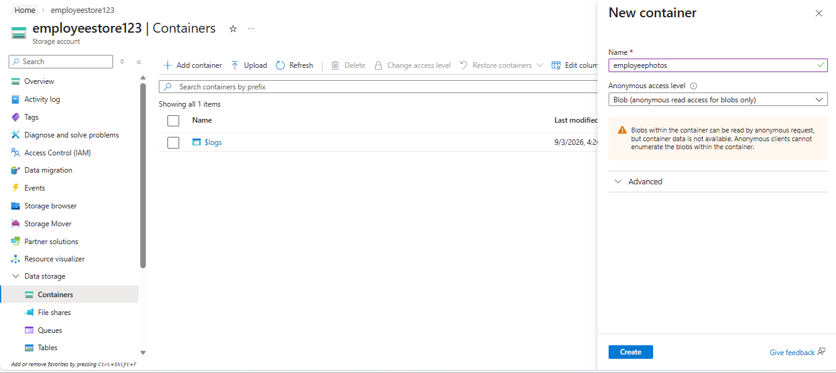
- Click Create.
Fig.3
Step 3 – Retrieve Connection String
- Inside the Storage Account, go to:
Security + Networking → Access Keys
- Copy the Connection String.

Example:
DefaultEndpointsProtocol=https; AccountName=employeestorage123; AccountKey=XXXXXXXX

This connection string allows the application to connect to Azure Storage.
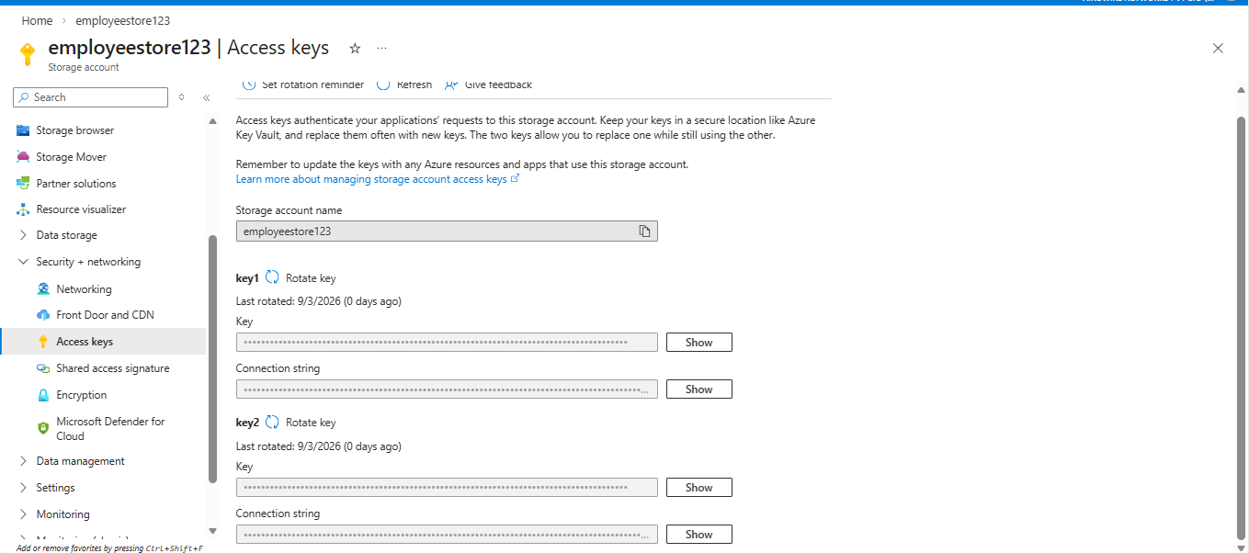
Fig .4
Step 4 – Create and connect to the Virtual Machine
To create Virtual Machine follow steps from first experiment

1: Login to VM:
Using SSH or RDP
2: Update system:
sudo apt update
3: Install venv package:
sudo apt install python3-venv -y
4: Create Application Folder:
mkdir employee-app
cd employee-app
5: Create Virtual Environment:
python3 -m venv venv
6: Activate Virtual Environment:
source venv/bin/activate
7: Install required Python packages:
pip install flask
pip install azure-storage-blob
8: Create Python file:
nano app.py

add the following code:
from flask import Flask, request, render_template
from azure.storage.blob import BlobServiceClient
app = Flask(__name__)
connection_string = "YOUR_CONNECTION_STRING"
container_name = "employeephotos"
blob_service_client = BlobServiceClient.from_connection_string(connection_string)
@app.route('/', methods=['GET','POST'])
def upload():
if request.method == 'POST':
file = request.files['photo']
blob_client = blob_service_client.get_blob_client(
container=container_name,
blob=file.filename
)
blob_client.upload_blob(file)
return "File uploaded successfully to Azure Blob Storage"
return render_template('index.html')
app.run(host="0.0.0.0", port=5000)

Replace: YOUR_CONNECTION_STRING
with the connection string copied from Azure Portal.
Hit Ctrl + s and ctrl + x to save and exit

Step 5 – Create HTML Form
Create a folder:
mkdir templates
Go inside templates folder
cd templates
create:
nano index.htm
Add the following code:
<!DOCTYPE html>
<html>
<head>
<title>Employee Photo Upload</title>
</head>
<body>
<h2>Employee Photo Upload</h2>
<form method="POST" enctype="multipart/form-data">
Name:
<input type="text" name="name"><br><br>
Team:
<input type="text" name="team"><br><br>
Upload Photo:
<input type="file" name="photo"><br><br>
<input type="submit" value="Upload">
</form>
</body>
</html>
Save the file:
CTRL + S
CTRL + X
Come out of the templates folder
Cd ..
Step 6 – Run the Application
Start the application:
python app.py
Output will show:
Running on http://0.0.0.0:5000

Step 7 – Access the Application
Open a browser and enter:
http://VM-PUBLIC-IP:5000
Your app is not opening because port 5000 is not allowed in NSG

Step 8 – Configure NSG Rule to Allow Application Port
- Go to the Virtual Machine (VM) in the Azure Portal
- In the left menu, click on Networking
- Click on Add inbound port rule
- Configure the rule as follows:
Setting | Value
Source | Any
Source port ranges | *
Destination | Any
Destination port ranges | 5000
Protocol | TCP
Action | Allow
Priority | 300
Name | Allow-Port-5000

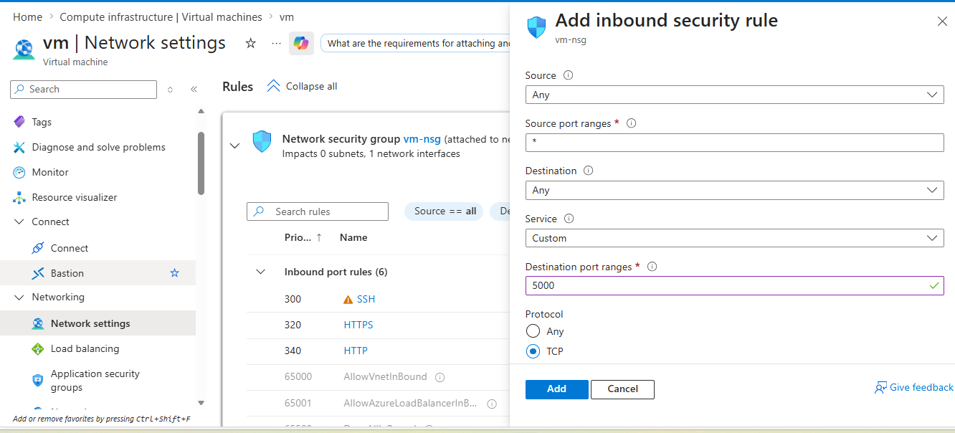
Click ADD Fig.5
Now run you application
The application page will appear.
you can now:
- Enter employee name
- Enter team
- Upload an employee photo
Click Upload.

Step 9 – Verify Uploaded File
Go to Azure Portal.
Navigate to:
Storage Account
→ Containers
→ employeephotos

Uploaded files will appear.
Example: rahul.jpg
employee1.png

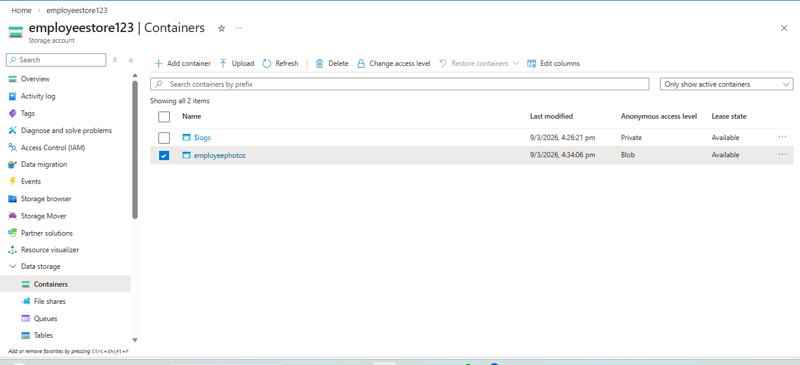
Fig.6
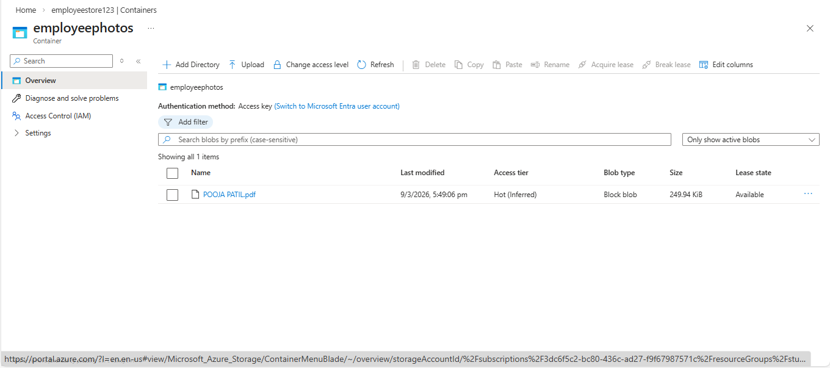
Fig.7

Step 10. Access the Uploaded Blob File in Browser
- Go to Azure Portal
- Open the Storage Account
- Navigate to:
Data Storage → Containers
- Click the container:
employeephotos
- Select the uploaded file (example: rahul.jpg)
- Click Copy URL

Example URL:
https://employeestorage123.blob.core.windows.net/employeephotos/rahul.jpg
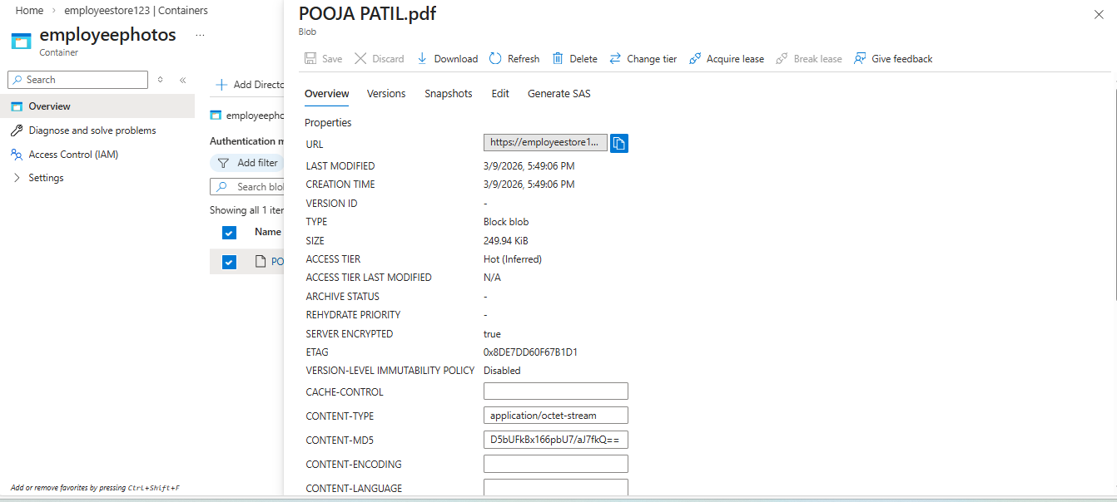
Fig.8

- Paste the URL into a browser.
The file will open directly from Azure Blob Storage.

4. Result
The Python web application successfully uploads files to Azure Blob Storage.
You have learned how to:
- Create and configure Azure Storage
- Use Blob Containers
- Connect an application to Azure Storage
- Upload files from a web application

